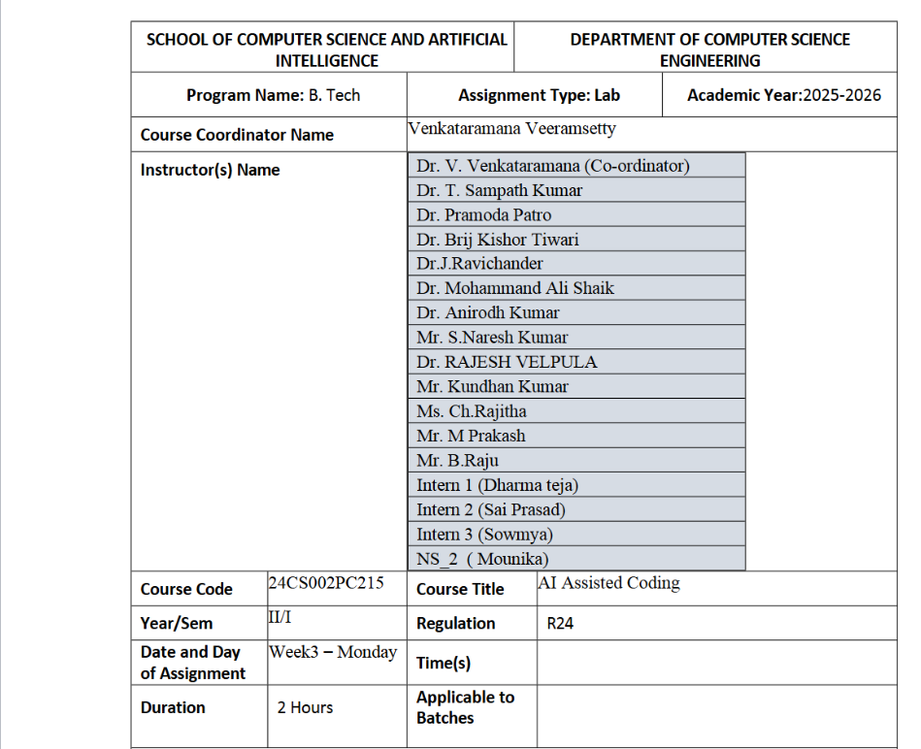
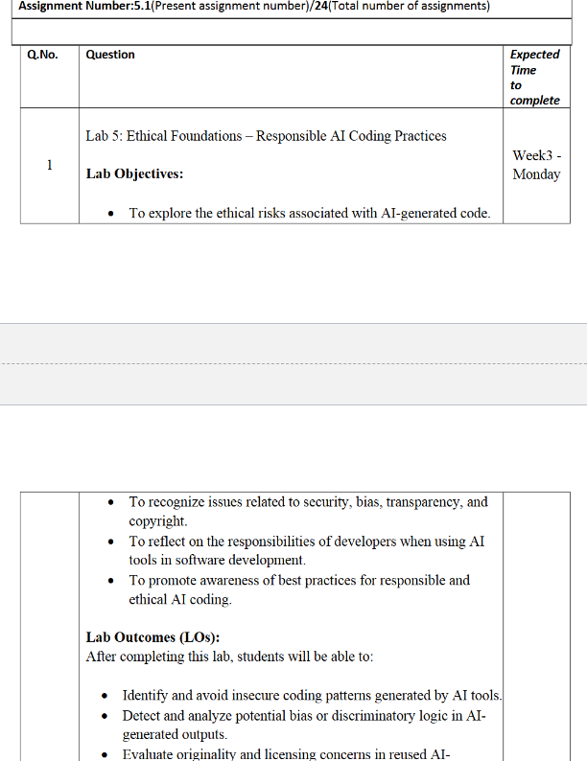
Task Description #1 (Privacy in API Usage)
Task: Use an AI tool to generate a Python program that connects to a
weather API.
Prompt:
"Generate code to fetch weather data securely without exposing API
keys in the code."
Expected Output:
• Original AI code (check if keys are hardcoded).
• Secure version using environment variables
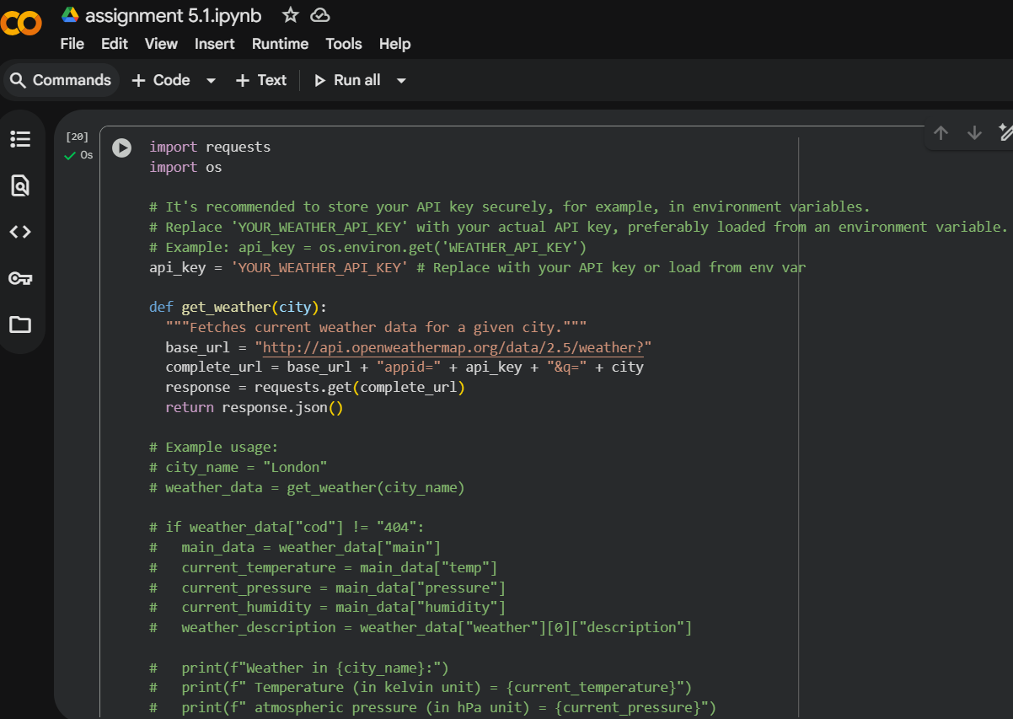
Task Description #2 (Privacy & Security in File Handling)
Task: Use an AI tool to generate a Python script that stores user data
(name, email, password) in a file.
Analyze: Check if the AI stores sensitive data in plain text or without
encryption.
Expected Output:
• Identified privacy risks.
• Revised version with encrypted password storage (e.g., hashing).
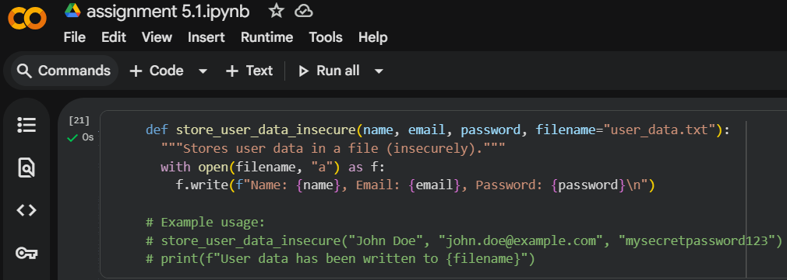
Task Description #3 (Transparency in Algorithm Design)
Objective: Use AI to generate an Armstrong number checking function
with comments and explanations.
Instructions:
1. Ask AI to explain the code line-by-line.
2. Compare the explanation with code functionality.
Expected Output:
• Transparent, commented code.
• Correct, easy-to-understand explanation
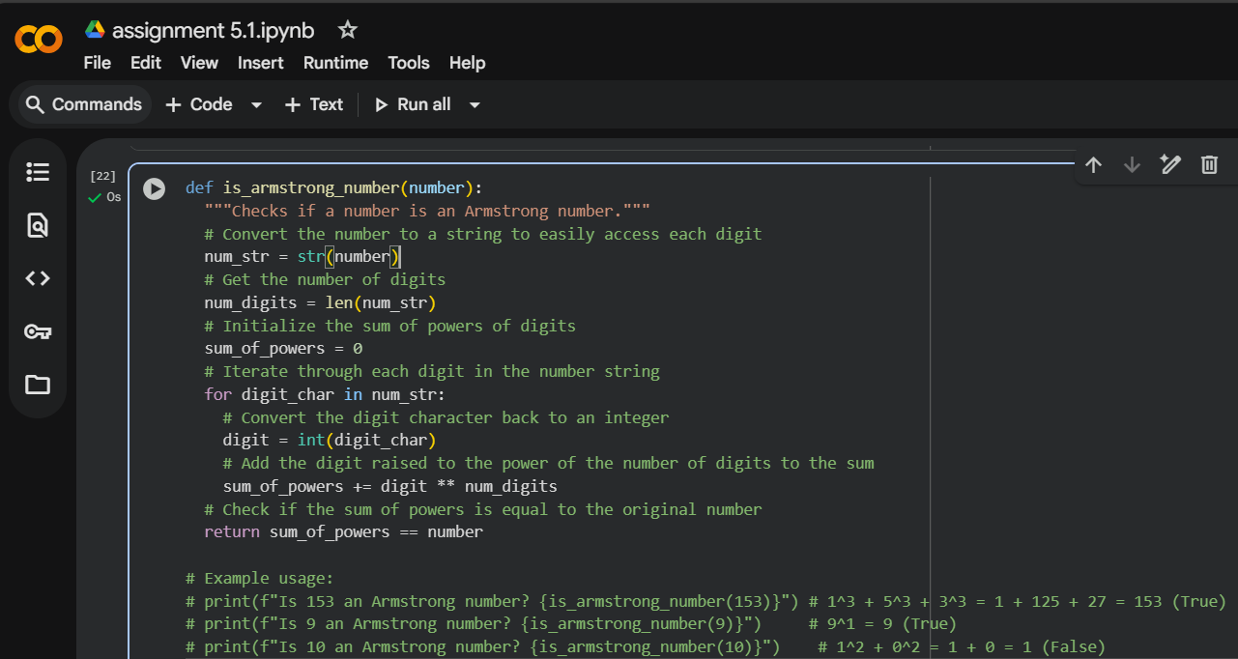
Task Description #4 (Transparency in Algorithm Comparison)
Task: Use AI to implement two sorting algorithms (e.g., QuickSort and
BubbleSort).
Prompt:
"Generate Python code for QuickSort and BubbleSort, and include
comments explaining step-by-step how each works and where they
differ."
Expected Output:
• Code for both algorithms.
• Transparent, comparative explanation of their logic and
efficiency.
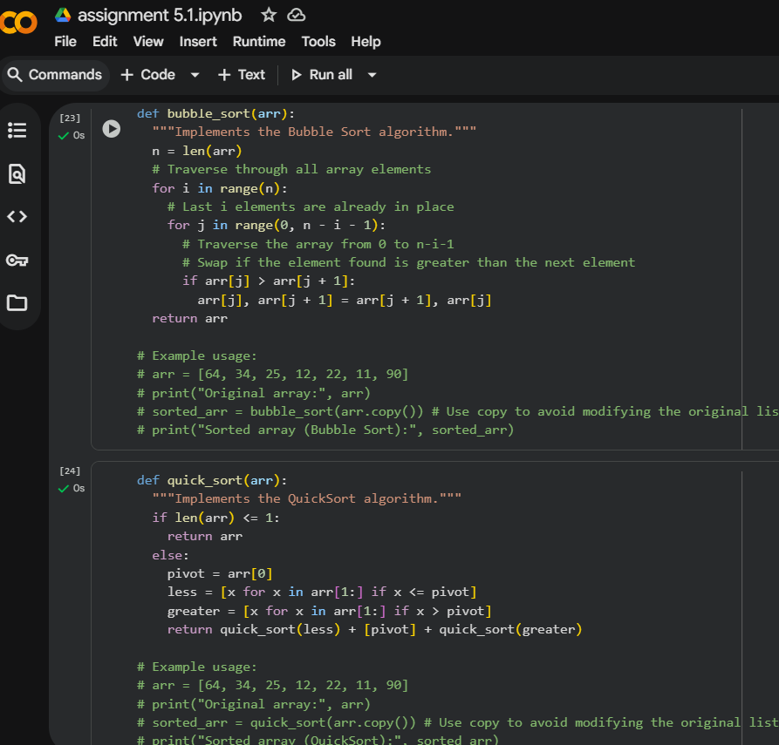
Task Description #5 (Transparency in AI Recommendations)
Task: Use AI to create a product recommendation system.
Prompt:
"Generate a recommendation system that also provides reasons for
each suggestion."
Expected Output:
• Code with explainable recommendations.
• Evaluation of whether explanations are understandable
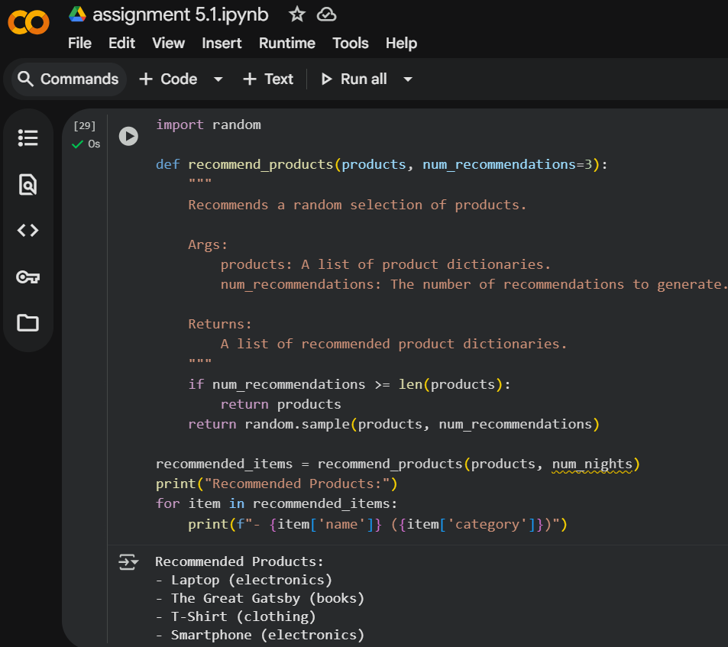
Task Description #6 (Transparent Code Generation)
Task: Ask AI to generate a Python function for calculating factorial
using recursion.
Prompt:
"Generate a recursive factorial function with comments that explain
each line and a final summary of the algorithm’s flow."
Expected Output:
• Fully commented code.
• Clear documentation of how recursion works.
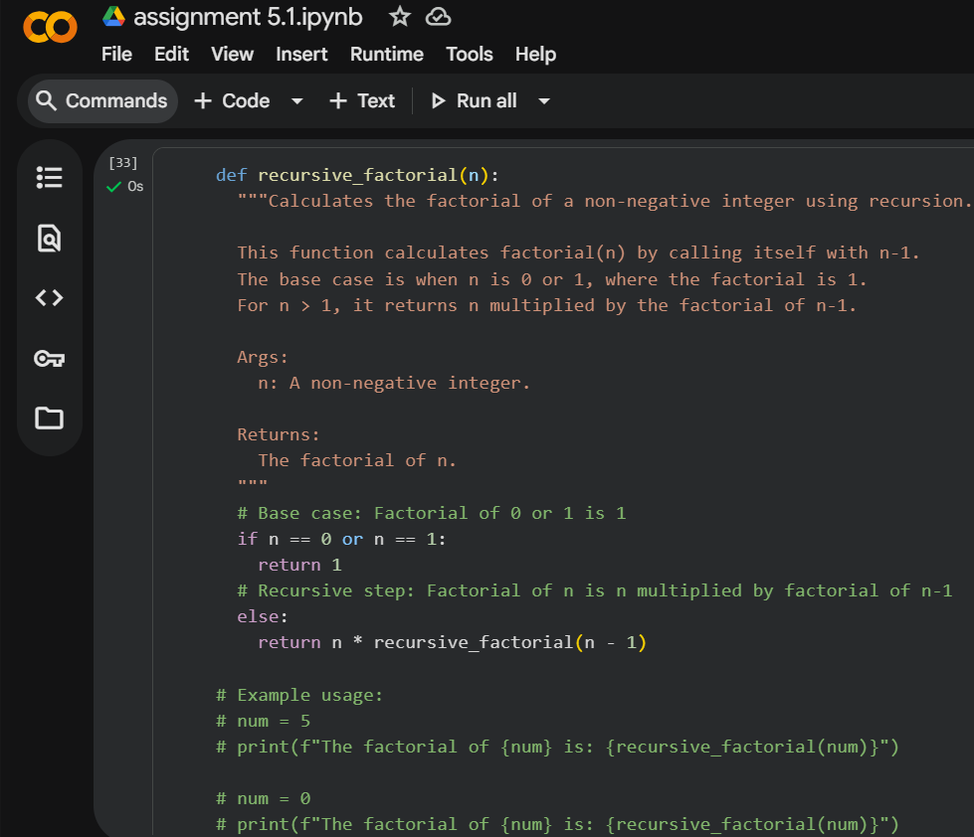
Task Description #7 (Inclusiveness in Customer Support)
Code Snippet:
Task:
Regenerate the code so that support messages use neutral language (e.g.,
“Dear {name}”) and optionally accept preferred titles.
Expected Output:
• Neutral, user-friendly support responses

CODE:
def support_reply(name, gender=None, title=None):
"""
Generates a neutral, inclusive support reply message.

Parameters:
name (str): The customer's name.
gender (str, optional): Kept for compatibility, but not used for titles.
title (str, optional): Custom preferred title (e.g., 'Dr.', 'Mx.', etc.).

Returns:
str: A neutral, user-friendly support response.
"""
if title:
greeting = f"Dear {title} {name},"
else:
greeting = f"Dear {name},"

message = f"{greeting} we have resolved your issue. Thank you for reaching out to our support team!"
return message

# Example usage:
print(support_reply("Alex", gender="male"))
print(support_reply("Jordan", gender="female", title="Dr."))
print(support_reply("Taylor", title="Mx."))
print(support_reply("Sam"))

